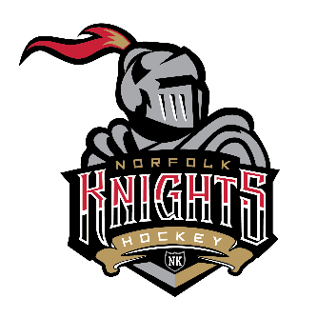
NORFOLK MINOR HOCKEY
ACCEPTS E-TRANSFERS!

Please follow these steps to Register and Pay via E-Transfer:
1) Use the registration link found there: REGISTER
2) Once you proceed to check-out – select “Cheque” as your method of payment
3) Through your bank provider, send payment of the total amount due via E-TRANSFER to: Hosack@mhnlawyers.com
Please add a NOTE in the e-transfer indicating the PLAYERS NAME(S) associated with this payment.
You will be required to add a password and hint.

